**A) Core Items**

1. Manufacturing engineering feats for controllers with fairness and without bias towards each customer’s disability.
2. Accounting for the many unique and different handicaps that each customer has and maintaining their specific blueprints for their accessories.
3. Maintaining a proper relationship with the many faces of the gaming industry to make our products usable and viable on all gaming platforms.
4. Pruning anti-disability remarks and tactics and ensuring the ability to fully use our products without the extra cost or tedious work.
5. Developing new strategies to keep product engineering costs stable and not employ anti-consumerism tactics.
6. Building relationships between the employees, the customers, the gamers, and the overall community.

**B) Board**

1. Taeha Types

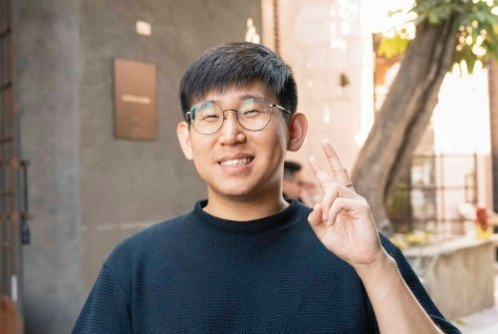

* Taeha Types is a content creator on YouTube. His channel is about custom mechanical keyboards. He is a very well-known creator in the custom keyboard community and has made keyboards for many other creators and professional gamers such as Tfue. Tfue is one of the most well-known professional gamers and his keyboard is fully custom-made by Taeha Types. We think Taeha Types would be a great fit for our board because he has a lot of experience in product making and we feel like he could help us create a product that would make keyboards more accessible for our customers.

1. Michael Reeves



* Michael Reeves is a content creator on YouTube. He creates content related to engineering and software. We feel like Michael Reeves would be a great fit for our board because of his multi-varied expertise in creating software and engineering feats that complement each other in achieving their specific goals. He is good at coding and creating products, so he could help us design and create new products that help us with our business plans.

1. Marc Andreessen

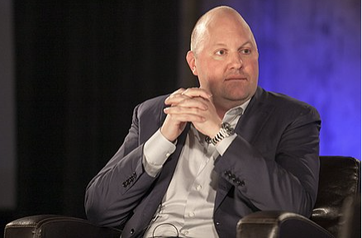

* Marc Andreessen is a software engineer and an American investor/businessman. He is the co-founder of Mosaic, which was the first web browser with a graphical UI that was used widely. He also co-founded the Silicon Valley venture capital firm, Andreessen Horowitz. We think Marc Andreessen would be a great member of our board because he was one of the original inventors who utilized the World Wide Web efficiently and he is also a successful founder and investor. He could provide us with priceless advice on our technology, and our business plans.